iText
A Rich Text Editor Using C#

User Manual

A Mini Project



S.Maheshwaran
III BE (CSE)
Sona College of Technology.
E-Mail: mahesh_monu@yahoo.com

April 2004

Sona College of Technology, Salem-5

Department of Computer Science and Engineering

PROJECT WORK

Certificate

This is to certify that the contents of the project report entitled as iText is the bonafide record of work done by Maheshwaran.S Register. No 61801104036 of Department of Computer Science during the academic year 2003-2004.

Head of Department Faculty Guide

Successful iText project is
Dedicated to my Mother

Contents

Contents
Contents | Page
Acknowledgement | 5
Abstract | 7
- Introduction  - Features of the project | 9
- System Requirements | 12
- Inside iText | 13
- Conclusion | 44
- Bibliography | 46

Acknowledgement

Acknowledgement
We hereby express our deep sense of gratitude to the Management of Sona College of Technology for their kind encouragement to complete this project.
We are grateful to express our sincere thanks to our beloved principal Prof.M.Ramaswamy, B.E., M.Sc (Engg.), MISTE, for their cooperation and for providing excellent facilities to this project.
I also express my sincere thanks to our Head of the Department Prof.Annadurai Ph.D, our project coordinator and guide Mrs.Lakshmi M.E. for their valuable suggestions, encouragement, timely advice and co-operation to do this project in a successful manner.
Also I express my profound and sincere thanks to all the staff members and Lab Technicians of Department of Computer Science and Engineering in our college for their valuable guidance and encouragement given to complete this project. Finally, I thank my beloved parents for their moral support and economical support.

Abstract

iText
A Rich Text Editor in “C#“

Abstract

iText is a text editor programmed entirely in “C#”. Like any other editor, iText also has a variety of features to make the user comfortable working in it. The main idea of creating an editor in C# is that the language is so powerful that an editor created using C# can be used an editor in programming C# programs itself.
Some of the features of iText are as follows:
- It provides a wide variety of editing options like Cut,Copy,Paste,Find,Find Next, Go To, to mention a few out of the eleven Edit menu options.
- It provides an Image Viewer to help users have a view of various pictures of various formats like .bmp, .jpeg etc.
- Different fonts with different colors can be used.
- The Help Menu provides a “User Manual” to guide users in working with iText.
- The Help Menu also provides a manual about the implementation details.
- Additional feature of iText is that in spite of using a large number controls it is fast and it highly caters to the expectations of the user.
Future enhancements that are to be incorporated in iText are
- Converting a text file into .jpeg file for use in other documents
- Feature of saving a file in .xml format
- Powerful search through “regular expressions”
- Making this compatible with “Linux” with the release of “Mono”, the C# being developed for Linux.

Introduction

Introduction
2.1 Features of the project:
This is a mini project that was done entirely “C#”. The reason for choosing C# was due to its strong object oriented concepts and the language by itself is easy to learn and master.
The main feature of the iText editor is that the text box used is a “Rich Text Box” which is one of the special controls that are available in C#. This text box can incorporate a lot of features like images, pictures and a variety of other such features.iText is different from any other normal editor as in a number of ways like it provides the user an “Image Viewer” to view pictures.
The other important feature of iText is that the size of the software is very small around 25KB and hence its system requirements are limited.

System Specification

System Specification

Hardware Specification:
Processor | 650 MHz
SDRAM | 128 MB
Cache | 64 MB
FDD | 1.44”
HD | 30 GB
Monitor | 15” Color Monitor
Keyboard | 108 Keys Wipro Keyboard

Software Specification:

Operating System | Microsoft ® Windows 2000 ,Windows XP
SDK | C#

Inside iText……

Main Window of iText:

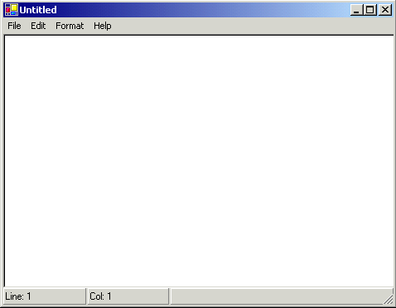

iText has four menus namely
- File Menu
- Edit
- Format
- Help

File Menu

New:

private void DoNew()
{
if(IsContentModified)
{
string Message="The text in the " + this.Text + " has been changed.\n Do you want to Save Changes?";
switch(MessageBox.Show(Message,"SuperPad",MessageBoxButtons.YesNoCancel))
{
case DialogResult.Yes:
DoSave();
txtCPad.Text="";
this.Text="Untitled";
break;
case DialogResult.No:
txtCPad.Text="";
this.Text="Untitled";
break;
case DialogResult.Cancel:
break;
}
}
else
{
txtCPad.Text="";
this.Text="Untitled";
}
}

Open:
GUI View:
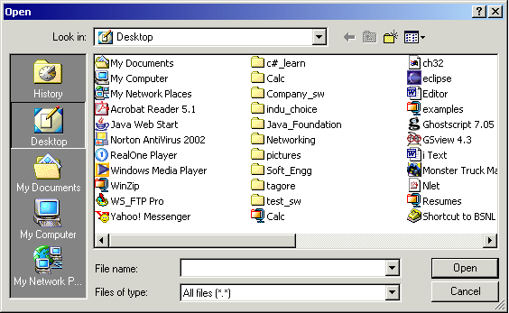
Source Code:
private void DoOpen()
{
OpenFileDialog dlgOpen=new OpenFileDialog();
dlgOpen.Filter="All files (*.*)|*.*|All files (*.*)|*.*";
dlgOpen.FilterIndex=2;
dlgOpen.RestoreDirectory=true;
string FileName="";
if(dlgOpen.ShowDialog()==DialogResult.OK)
{
try
{
FileName=dlgOpen.FileName;
FileStream fs=File.OpenRead(FileName);

txtCPad.Text="";
string strLine="";
int c;
while((c=fs.ReadByte())!=-1)
{
strLine+=(char)c;
}
txtCPad.Text+=strLine+"\n";
txtCPad.SelectionStart=0;
txtCPad.SelectionLength=0;
this.Text=FileName;
fs.Close();

}
catch(Exception e)
{
MessageBox.Show("Error Occurred:\n" + e.ToString());
}
}
}

Save:
GUI View:
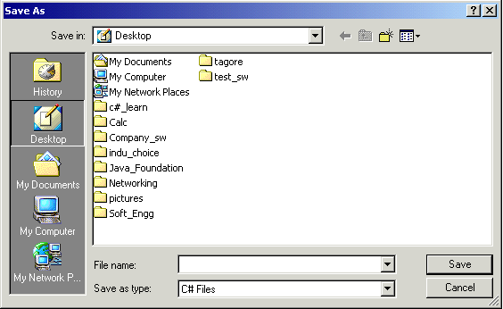
Source Code:
public void DoSave()
{
if(this.Text=="Untitled")
{
DoSaveAs(true);
}
DoSaveAs(false);
IsContentModified=false;
}
public void DoSaveAs(bool ShowDialog)
{
bool CanWrite=false;
SaveFileDialog dlgSave=new SaveFileDialog();
dlgSave.Filter="Text Files (*.txt)|*.txt|C# Files|*.cs|All Files (*.*)|*.*";
dlgSave.FilterIndex=2;
dlgSave.RestoreDirectory=true;
string FileName="";
if(ShowDialog)
{
if(dlgSave.ShowDialog()==DialogResult.OK)
{
FileName=dlgSave.FileName;
CanWrite=true;
}
}
else
{
FileName=this.Text;
CanWrite=true;
}
if(CanWrite)
{
try
{
StreamWriter sw=File.CreateText(FileName);
sw.Write(txtCPad.Text);
sw.Flush();
sw.Close();
this.Text=FileName;
}
catch(Exception e)
{
MessageBox.Show(e.ToString());
}
}

}

Save As:
GUI View:
Source Code:
public void DoSaveAs(bool ShowDialog)
{
bool CanWrite=false;
SaveFileDialog dlgSave=new SaveFileDialog();
dlgSave.Filter="Text Files (*.txt)|*.txt|C# Files|*.cs|All Files (*.*)|*.*";
dlgSave.FilterIndex=2;
dlgSave.RestoreDirectory=true;
string FileName="";
if(ShowDialog)
{
if(dlgSave.ShowDialog()==DialogResult.OK)
{
FileName=dlgSave.FileName;
CanWrite=true;
}
}
else
{
FileName=this.Text;
CanWrite=true;
}
if(CanWrite)
{
try
{
StreamWriter sw=File.CreateText(FileName);
sw.Write(txtCPad.Text);
sw.Flush();
sw.Close();
this.Text=FileName;
}
catch(Exception e)
{
MessageBox.Show(e.ToString());
}
}

}

Exit:
Source Code:
this.Dispose();
Application.Exit();

Edit Menu

Undo:
Source Code:
private void DoUndo()
{
if(txtCPad.CanUndo)
{
txtCPad.Undo();
TextBox_KeyUp(null,null);
}
}
//To Set Line,Col in StatusBar
private void TextBox_KeyUp(object sender,KeyEventArgs kArgs)
{
try
{
int ColCount=1;
int RowCount=1;
int Pos;
//To Set Column
if(txtCPad.SelectionStart>-1)
{
Pos=txtCPad.Text.LastIndexOf("\n",txtCPad.SelectionStart);
if(Pos>-1)
{
//If the cursor is at CRLF
if(Pos!=txtCPad.SelectionStart)
ColCount=txtCPad.SelectionStart-Pos;
else
{
//Col position is diff between PrevEnter and CurPos
Pos=txtCPad.Text.LastIndexOf("\n",txtCPad.SelectionStart-1);
ColCount=txtCPad.SelectionStart-Pos;
}
}
else
{
ColCount=txtCPad.SelectionStart+1;
}
while(Pos>-1)
{
RowCount++;
Pos=txtCPad.Text.LastIndexOf("\n",Pos-1);
}
}
sbCPad.Panels[1].Text="Col: " + ColCount.ToString();
sbCPad.Panels[0].Text="Line: " + RowCount.ToString();
}
catch(Exception)
{
}
}

Cut:
Source Code:
private void DoCut()
{
if(txtCPad.SelectedText!="")
{
txtCPad.Cut();
TextBox_KeyUp(null,null);
}

}

Copy:
Source Code:
private void DoCopy()
{
if(txtCPad.SelectedText!="")
{
flag=true;
txtCPad.Copy();
TextBox_KeyUp(null,null);
}
}
Paste:
Source Code:

private void DoPaste()
{
if(flag){
txtCPad.Paste();
TextBox_KeyUp(null,null);
}

}

Delete:
Source Code:

if(txtCPad.SelectionLength==0)
txtCPad.SelectionLength=1;
txtCPad.SelectedText="";

Find:
GUI View:
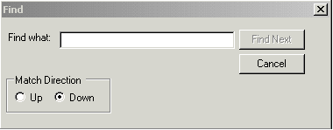
Source Code:
private void ShowFind()
{
TextBox txtFind=new TextBox();
Label lblFind=new Label();
CheckBox chkMatch=new CheckBox();
GroupBox grpDirection=new GroupBox();
RadioButton optUp=new RadioButton();
RadioButton optDown=new RadioButton();
Button cmdOK=new Button();
Button cmdCancel=new Button();

cmdOK.Text="Find Next";
cmdOK.DialogResult=DialogResult.OK;
cmdOK.Click+=new EventHandler(Find_Click);

cmdCancel.Text="Cancel";
cmdCancel.DialogResult=DialogResult.Cancel;
cmdCancel.Click+=new EventHandler(Cancel_Click);

Form frmDialog=new Form();
frmDialog.Size=new Size(380,150);
frmDialog.Text="Find";
frmDialog.MaximizeBox=false;
frmDialog.MinimizeBox=false;
frmDialog.FormBorderStyle=FormBorderStyle.FixedDialog;

lblFind.Location=new Point(5,15);
lblFind.Text="Fi&nd what:";
lblFind.AutoSize=true;

txtFind.Location=new Point(lblFind.Left+lblFind.Width+5,lblFind.Top);
txtFind.Size=new Size(200,txtFind.Height);
txtFind.Text=TextToFind;
txtFind.TextChanged+=new EventHandler(txtFind_Change);

cmdOK.Location=new Point(txtFind.Left+txtFind.Width+5,lblFind.Top-2);
cmdCancel.Location=new Point(cmdOK.Left,cmdOK.Top+cmdOK.Height+5);

grpDirection.Location=new Point(lblFind.Left,cmdCancel.Top+cmdCancel.Height);
grpDirection.Size=new Size(120,45);
grpDirection.Text="Match Direction";

optUp.Location=new Point(10,15);
optUp.Click+=new EventHandler(Direction_Click);
optUp.Text="&Up";
optUp.Width=45;

optDown.Text="&Down";
optDown.Width=55;
optDown.Click+=new EventHandler(Direction_Click);
optDown.Checked=true;
optDown.Location=new Point(optUp.Left+optUp.Width,optUp.Top);

grpDirection.Controls.Add(optUp);
grpDirection.Controls.Add(optDown);

chkMatch.Location=new Point(grpDirection.Left+grpDirection.Width+5,grpDirection.Top+(grpDirection.Height-chkMatch.Height)/2);
chkMatch.Text="Match Case";

if(txtFind.Text.Trim().Length==0) cmdOK.Enabled=false;

frmDialog.Controls.Add(txtFind);
frmDialog.Controls.Add(lblFind);
frmDialog.Controls.Add(grpDirection);
frmDialog.Controls.Add(cmdOK);
frmDialog.Controls.Add(cmdCancel);
frmDialog.ShowInTaskbar=false;
frmDialog.TopMost=true;
frmDialog.Show();
}

Find Next:
Source Code:
private void Find_Click(object sender,EventArgs eArgs)
{
int Pos=-1;

if(IsDirectionDownward)
{
if(txtCPad.SelectionLength==0)
Pos=txtCPad.Text.IndexOf(TextToFind,txtCPad.SelectionStart);
else
Pos=txtCPad.Text.IndexOf(TextToFind,txtCPad.SelectionStart+txtCPad.SelectionLength);
}
else
{
if(txtCPad.SelectionStart>0)

Pos=txtCPad.Text.LastIndexOf(TextToFind,txtCPad.SelectionStart-1);
}
if(Pos!=-1)
{
txtCPad.SelectionStart=Pos;
txtCPad.SelectionLength=TextToFind.Length;
if(sender!=null) ((Control)sender).Focus();
}
else
{
MessageBox.Show("Cannot Find: \"" + TextToFind + "\"");
}
}
GoTo:
Source Code:
public void MoveToLine(int LineNumber)
{
int CRPosition=txtCPad.Text.IndexOf("\n");
int LineCount=0;
bool IsMoved=false;
while(CRPosition >-1 && !IsMoved)
{
LineCount++;
if(LineNumber==LineCount)
{
txtCPad.SelectionStart=CRPosition-1;
TextBox_KeyUp(null,null);
IsMoved=true;
}
CRPosition=txtCPad.Text.IndexOf("\n",CRPosition+1);
}
if(!IsMoved)
{
if(LineNumber==LineCount+1)
txtCPad.SelectionStart=txtCPad.Text.Length;
else
MessageBox.Show("Line Number Out of Range");
}
}

Select All:
Source Code:
txtCPad.SelectionStart=0;
txtCPad.SelectionLength=txtCPad.Text.Length;

Time/Date:
Source Code:

txtCPad.SelectedText=DateTime.Now.ToString();

Format Menu

Word Wrap:
Source Code:
((MenuItem)sender).Checked=!((MenuItem)sender).Checked;
txtCPad.WordWrap=((MenuItem)sender).Checked;

Font:
GUI View:
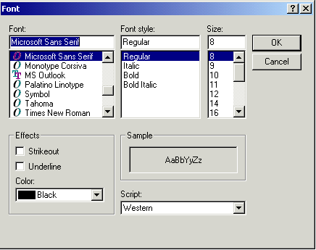
Source Code:
public void SetFont()
{
FontDialog dlgFont=new FontDialog();
dlgFont.Font=txtCPad.Font;
dlgFont.ShowColor=true;
dlgFont.Color=txtCPad.ForeColor;
if(dlgFont.ShowDialog()==DialogResult.OK)
{
txtCPad.Font=dlgFont.Font;
txtCPad.ForeColor=dlgFont.Color;
}
}
Image Viewer:
GUI View:
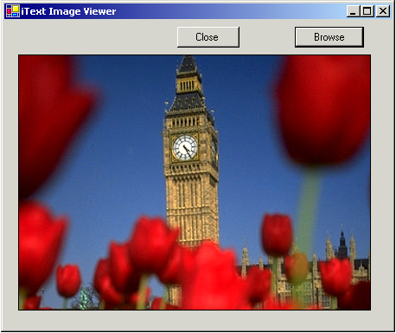

Source Code:

public class Form1:System.Windows.Forms.Form {

private System.ComponentModel.Container components;
private System.Windows.Forms.Button button3;
private System.Windows.Forms.Button button2;
private System.Windows.Forms.Button button1;

public Form1()
{
InitializeComponent();
}

public void InitializeComponent()
{
this.components=new System.ComponentModel.Container();
this.button3=new System.Windows.Forms.Button();
this.button2=new System.Windows.Forms.Button();
this.button1=new System.Windows.Forms.Button();

button2.Location=new System.Drawing.Point(16,40);
button2.FlatStyle=System.Windows.Forms.FlatStyle.Flat;
button2.Size=new System.Drawing.Size(408,296);
button2.TabIndex=1;

button3.Location=new System.Drawing.Point(200,8);
button3.Size=new System.Drawing.Size(72,24);
button3.TabIndex=3;
button3.Text="&Close";
button3.Click+=new System.EventHandler(this.button3_Click);

button1.Location=new System.Drawing.Point(336,8);
button1.Size=new System.Drawing.Size(80,24);
button1.TabIndex=2;
button1.Text="Browse";
button1.Click+=new System.EventHandler(this.button1_Click);

this.Text="iText Image Viewer";
this.AutoScaleBaseSize=new System.Drawing.Size(5,13);
this.ClientSize=new System.Drawing.Size(448,357);

this.Controls.Add(this.button3);
this.Controls.Add(this.button2);
this.Controls.Add(this.button1);

}

protected void button3_Click(object sender,System.EventArgs e)
{
this.Close();
}
protected void button1_Click(object sender,System.EventArgs e)
{
OpenFileDialog fdlg=new OpenFileDialog();
fdlg.Title="C# Projects Open File Dialog";
fdlg.InitialDirectory=@"C:\";
fdlg.Filter="All files (*.*)|*.*|All files (*.*)|*.*";
fdlg.FilterIndex=2;
fdlg.RestoreDirectory=true;

if(fdlg.ShowDialog()==DialogResult.OK)
{
button2.Image=Image.FromFile(fdlg.FileName);
}
Invalidate();
}

}

Help Menu

About:
Source Code:
MessageBox.Show("iText\n R.Indumathi\n Mini Project\n Email:indu_ashwini@rediffmail.com\nSona College of Technology");

User Manual:
Source Code:

MessageBox.Show("The User Manual is present in the folder containing the software");

Splash Screen

Splash Screen:
GUI View:
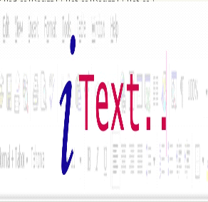
Source Code:

public class Class1
{
static System.Windows.Forms.Timer myTimer = new System.Windows.Forms.Timer();
static bool exitFlag = false;
Form2 f;

// This is the method to run when the timer is raised.
private static void TimerEventProcessor(Object myObject,
EventArgs myEventArgs)

{

exitFlag=true;
myTimer.Stop();
}

public Class1()
{
/* Adds the event and the event handler for the method that
will process the timer event to the timer. */
myTimer.Tick += new EventHandler(TimerEventProcessor);

// Sets the timer interval to 5 seconds.
myTimer.Interval = 5000;
f=new Form2();
f.Show();
myTimer.Start();
// Runs the timer, and raises the event.
while(exitFlag == false)
{
Application.DoEvents();
// Processes all the events in the queue.
}
f.Close();
//return 0;
}
}

class Form2 : System.Windows.Forms.Form
{
private System.Windows.Forms.PictureBox pictureBox1;
private System.ComponentModel.Container components = null;

public Form2()
{
//
// Required for Windows Form Designer support
//
InitializeComponent();
string path=@"C:\Documents and Settings\INDU\Desktop\iText_copy.jpg";
pictureBox1.Image = Image.FromFile(path);
}
protected override void Dispose( bool disposing )
{
if( disposing )
{
if (components != null)
{
components.Dispose();
}
}
base.Dispose( disposing );
}

private void InitializeComponent()
{
this.pictureBox1 = new System.Windows.Forms.PictureBox();
this.SuspendLayout();

this.pictureBox1.Name = "pictureBox1";
this.pictureBox1.Size = new System.Drawing.Size(296, 280);
this.pictureBox1.SizeMode = System.Windows.Forms.PictureBoxSizeMode.StretchImage;
this.pictureBox1.TabIndex = 0;
this.pictureBox1.TabStop = false;
this.AutoScaleBaseSize = new System.Drawing.Size(5, 13);
this.ClientSize = new System.Drawing.Size(292, 300);
this.Controls.AddRange(new System.Windows.Forms.Control[] {
this.pictureBox1});
this.FormBorderStyle = System.Windows.Forms.FormBorderStyle.None;
this.Name = "Form1";
this.Opacity = 0.9;
this.Text = "Form2";

this.ResumeLayout(false);

}

}

Conclusion

Conclusion:
C# provides an elegant way of creating forms and using controls.C# is being ported to Linux/Unix and so it can be said that C# like Java is also platform-independent. Be it console-mode program, GUI program, network program or even remoting, the C# version is easy to learn. This is a very well known fact and is not worth belaboring.
Thus I hope the ease with which this iText has been created would mirror the strength of C# as an outstanding object oriented language and this is the future…!

Bibiliography

Bibliography

- MSDN - Microsoft Developer Network
- Developer IQ Magazine
- C# Projects – Sambasiva Rao.K, KSR Publications

